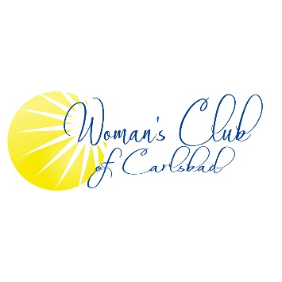
3320 Monroe Street, Carlsbad, CA 92008
Application for Membership
Date: _________

The Woman’s Club of Carlsbad is pleased to consider your application for membership in our club.
- As we are a service organization, in addition to our social time, we raise funds for scholarships and other philanthropic purposes
- Each member is required to be active in some field of these endeavors.
- Please check where you feel you could be helpful:

Ways & Means (fundraising) _____ Education _____ Crafts __________
Entre Nous (newsletter) _____ Literature ______ Health __________
International Affairs ______ Arts ______ Legislation _____

Membership: $50 - Annual Active Membership
$10 - New Members one-time processing fee

Name: _______________________________________________Spouse’s Name: __________________
Address: _____________________________________________________________________________
City & Zip Code: _______________________________________________________________
Home Ph # __________________________ Cell Ph #: ____________________________ Text: Yes/No
Email: _______________________________________________________________________________
Birth Date (Month/Day): ___________
Note: Membership fee must accompany this application
_____________________________________________________________________________________

